|  |  |  |  |  |  |  |  |
| --- | --- | --- | --- | --- | --- | --- | --- |
| **Date:** | **26-05-20** | | | | **Name:** | **SAHANA C** | |
| **Sem & Sec** | **VI B** | | | | **USN:** | **4AL17CS116** | |
| **Online Test Summary** | | | | | | | |
| **Subject** | | **CGV 2 IA Test** | | | | | |
| **Max. Marks** | | **30** | | **Score** | | **21** | |
| **Certification Course Summary** | | | | | | | |
| **Course** | **Front end development in HTML** | | | | | | |
| **Coding Challenges**  1)Write a Python Program to read a number n and print and compute the series “1+2+…+n=”.  2)Python Program to read a number n and #print the number of digits in it | | | | | | | |
| **Certificate Provider** | | | **Great learning** | **Duration** | | | **6DAYS** |
| **Status:Completed** | | | | | | | |
| **Uploaded the report in Github** | | | | **Yes** | | | |
| **If yes Repository name** | | | | https://github.com/sahanasanu/Daliy-status | | | | |
|  | | | | |
| **Uploaded the report in slack** | | | | **Yes** | | | |

**DAILY ONLINE ACTIVITIES SUMMARY**

**Ce Certification Details**

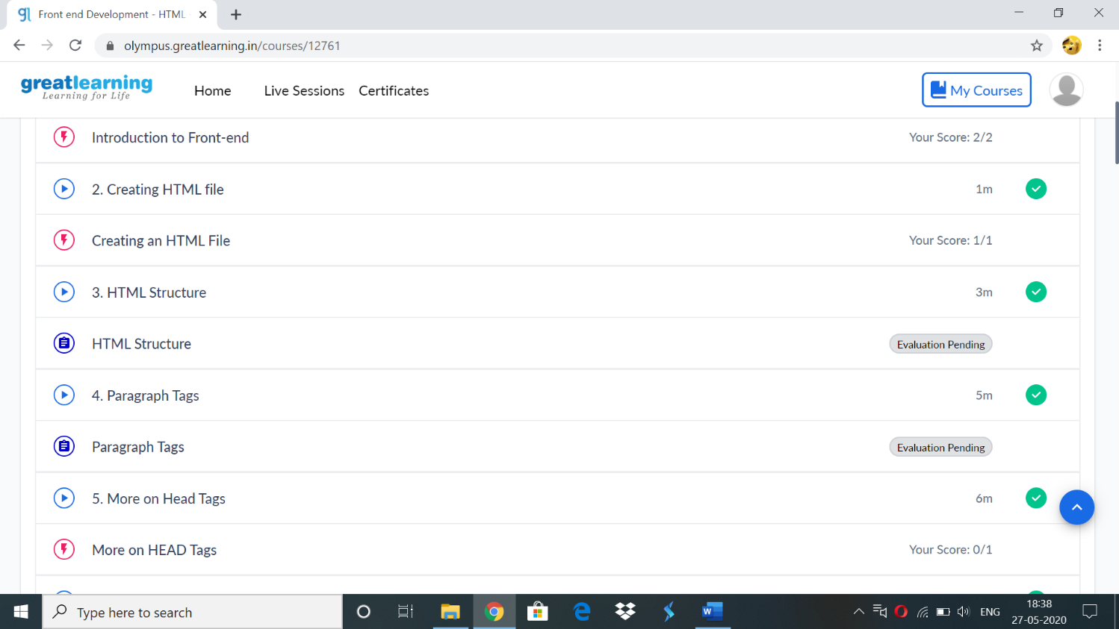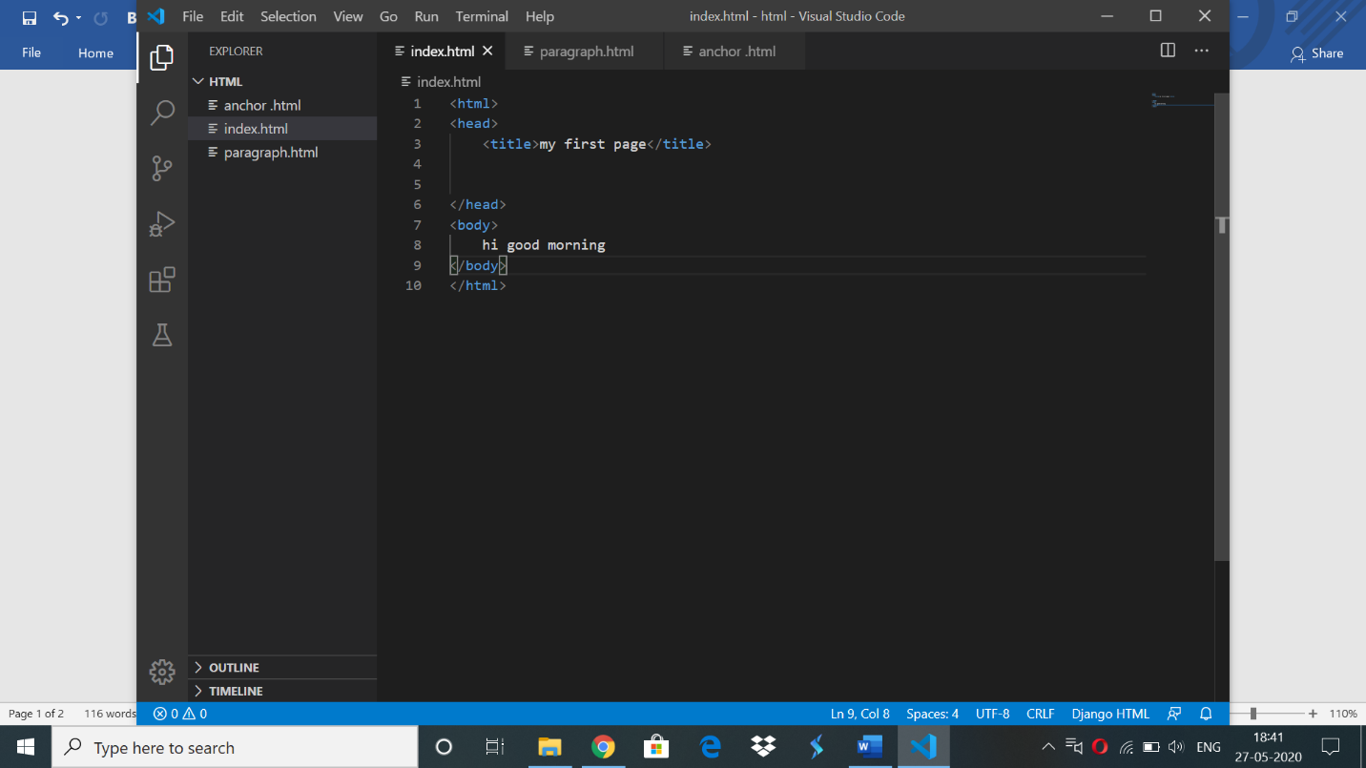

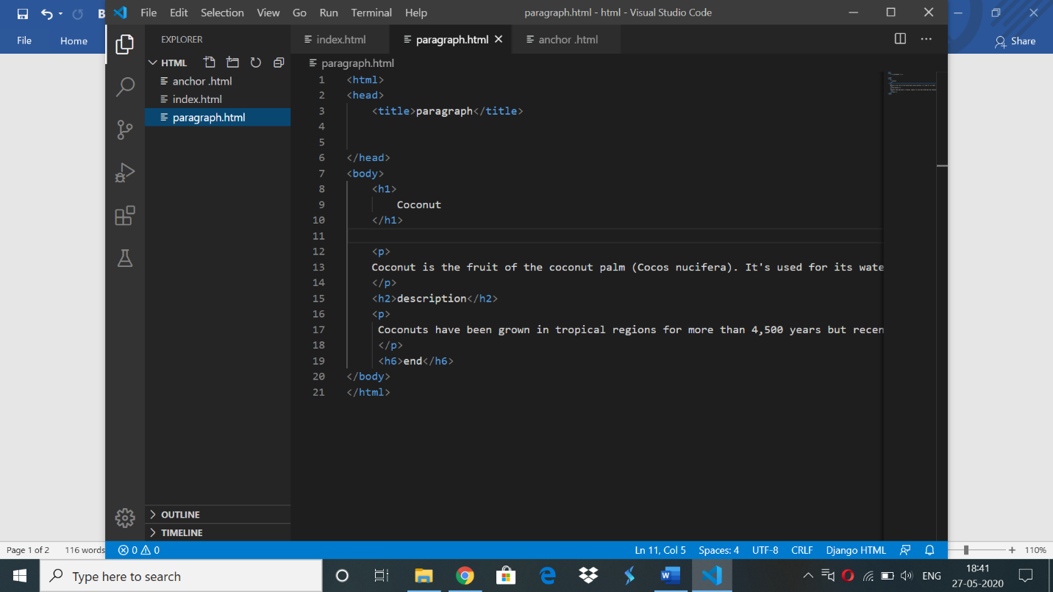

Online codding challenge:

1)Write a Python Program to read a number n and print and compute the series “1+2+…+n=”.

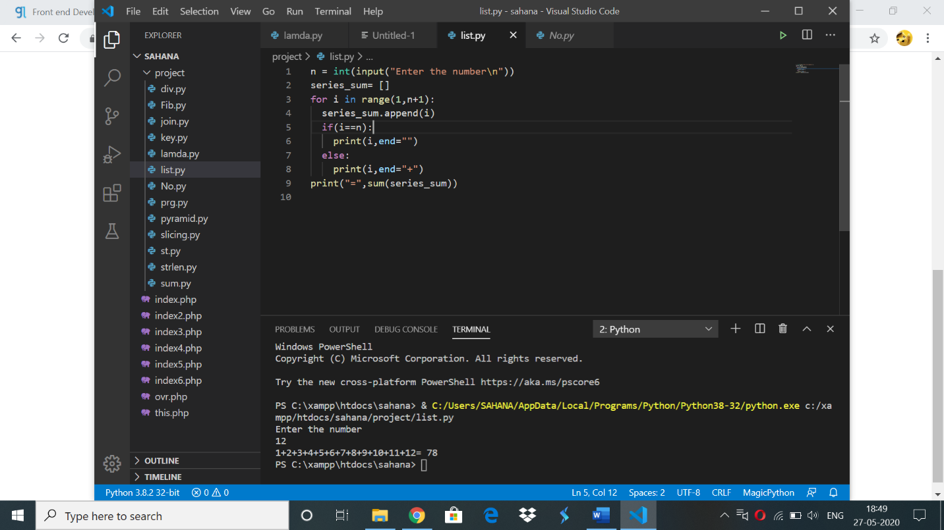

2) Python Program to read a number n and #print the number of digits in it

